autoFISH: fluidics system

**Overview** **2**

**Building the system** **3**

Connections 3

Used connectors 3

Tubing 4

Buffer storage 1: liquid handling robot 4

Add installation of drivers and control software. 4

Buffer storage 2: syringe holder 5

Automated valve 5

Configuring the valve 6

Pump 6

Bubble trap with vacuum pump 6

Flow sensor 7

Imaging chamber: BIOPTECHS FCS2 7

**Components** **8**

Peristaltic pump 9

Connection 9

**Controlling valves and pumps via the serial port** **9**

Which COM port? 9

Testing your hardware connected to a Serial port 10

MVP Valves 10

Pipette robot 10

REGLO Pump 11

# 

# Overview

This custom build fluidics system is based on a published paper for merFISH and ORCA (Moffit JR et al., 2016) but with some modified components as specified below. They main changes are

* **Bubble trap** to remove air bubbles
* **Flow sensor** to measured pumped volume after each step, and stop system in case a problem occurred
* **Pump placement** in the middle of the fluidics circuit. While it pulls liquid out of the different reservoirs, it pushes liquid through both the bubble trap and the imaging chamber. We found that this has several advantages:
  + Reduces air in the system
  + Permits to use the bubble trap efficiently
  + Reduces movement of the coverslip when pump is activated → reduced risk to loss focus
* Combined uses of **computer controlled valve** and **plate robot**: syringes for general purpose buffers, 96 well plate for round-specific buffers.

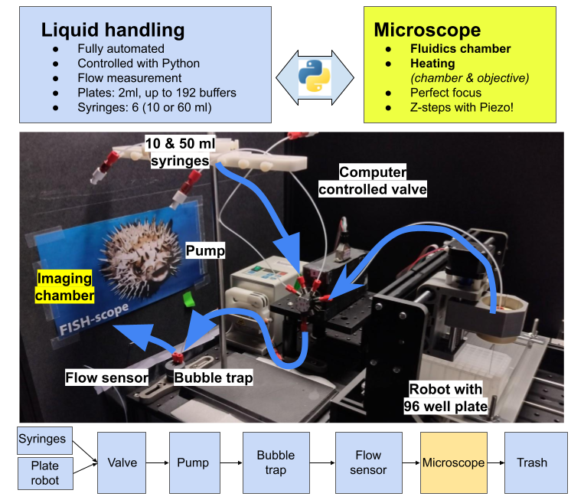

# 

# Building the system

Here, we describe how to build the system starting from the buffer storage to the flow-sensor. For a complete list of all required components, please consult the dedicated section Components.

## Connections

Several connectors are used to connect the tubing to the different components. Connections are **shown in blue**, we also provide pictures to show how these should be assembled. The two main connection types are:

* Most connections rely on a standard **¼-28 Threaded Connection**, where you use nut (blue) and a threaded connector (red) to connect the tube with another connector

|  |
| --- |

* Other connections are based on **male or female Luer locks** (commonly found on syringes). Show below is how such a Luer connector can be used in combination with a threaded connection to connect the fluidics tubing to a syringe.

|  |  |
| --- | --- |

### Used connectors

| P-658 | 1/4-28 Female to  Female Luer | Connects on syringe (male Luer) and connects to XP-202 |  |
| --- | --- | --- | --- |
| XP-202 | Flangeless Fitting Delrin,   * 1/4-28 Flat-Bottom * For 1/16" OD | Connect tubing to a threaded ¼-28 Port. |  |
| P-655 | Luer Adapter Assembly  1/4-28 Female to Male Luer | Connects to output of valve (female Luer) allows attachment of XP-202 |  |
| P-646 | Barbed to Threaded Male for soft 1/16" ID tubing, ¼ -28 male | To connect soft tubing (imaging chamber) |  |
| P-603 | Standard Union Delrin, ¼-28 Port | Screws on IDEX P-646 and allows connection of XP-202 |  |
| P-692 | Conical adaptor for soft tubing, ¼-28 male. | To connect soft tubing (vacuum pump) |  |

## Tubing

We use tubing made out of TEFZEL/ETFE with a rather small inner diameter (ID =0.5mm = 0.020") to minimize the amount of required liquid. The other diameter OD is standard for many fluidics applications (OD = 1/16" x 0.50mm).

## Buffer storage 1: liquid handling robot

We used a 3D CNC robot, where we replaced the CNC router with a custom printed syringe holder. We also used a plexiglas with 2D cutouts for two 96 well plates.

| * **Model**: CNC 3018 Pro * **Important**: has to be controlled by **GRBL** * **Hamilton needle** * **Connection**: **IDEX P-655 and P-202**   **Note: we glued the connectors together**, since they can wiggle free when the robot moves a lot. |  |
| --- | --- |

### Needle holder

| We 3d printed a needle holder that fits in the spindle holder. This is essentially a cylinder with a central hole to accommodate the needle.  We further added a headless screw that can be used to secure the needle firmly. |  |
| --- | --- |

### 96 well plate holder

| To securely place the 96 well plates on the robot, we use a holder made of sturdy cardboard or plexiglass. |  |
| --- | --- |

### Construction and testing of robot

1. Build according to instructions.Once build, you should already be able to move the robot with the provided joystick.
2. Install provided driver (for our robot it was named CH340SER.exe)
3. Connect USB to computer.
4. Determine your Machine's COM port (see below).
5. Open provided control software (for our robot grblControl)
6. Attempt to move the robot from within the software.
7. If this works, you should be able to use the robot in our Python control software.

## Buffer storage 2: syringe holder

| For general purpose buffers, e.g. for washing or imaging, we use syringes (either 10 or 50ml) with a female Luer lock.  They are placed in a syringe holder (**Warner Instruments 64-0143)** and  **Connection**: **P-658 and XP-202** |  |
| --- | --- |

| When the system is not used, we wash all fluidic lines with water and remove the syringes. We close the connectors (P-658) with a lid (the ones shown on the right come from a purification kit and are used to close purification columns). |  |
| --- | --- |

## Automated valve

We use computer controlled valves with several inputs (8 for the one listed below) and one output. Several companies produce such valves, we use the ones of **Hamilton**. Here you will need the valve positioner as well as the valve itself. The valve positioner is delivered with a power supply and control cable.

| Shown on the right is the valve itself with 4 connected inputs (ports 4 to 7) and one output.  Inputs are connected with threaded connections, output is connected with a female Luer.   * **Entry**: **Idex XP-202** * **Exit**: **Idex P-655 + XP-202** |  |
| --- | --- |

## Configuring the valve

| **Address switch** The Address Switch is set such that the first MVP/4 is set to “0,” second to “1,” and so forth. |  |
| --- | --- |

**DIP and termination switches**

You have to change the

* **DIP switches** (4-6) to indicatethatthe used valve has 8 ports (Table 2-2, page 14).
* Termination switch (7-8) have to be set to indicate that we only have one valve.

| SWITCH | 4 | 5 | 6 | 7 | 8 |
| --- | --- | --- | --- | --- | --- |
|  | ON | ON | OFF | ON | OFF |

## Pump

We currently support two different options.

### Peristaltic pump

| * Ismatec REGLO DIGITAL MS2/12-160, 230 or similar * Needs to be controllable via the serial port. * **Entry & exit**: **Blunt Gauge 25 needles (OD 0.54mm) with Luer Lock. +** **P-655 + XP-202** |  |
| --- | --- |

## Bubble trap with vacuum pump

We use a **bubble trap** to remove air bubbles from the buffers (especially EC is degassing). The bubble trap can be connected to a **vacuum pump** which will help to increase bubble removal. We use a small piezo pump, the pump itself is very cheap, the controller is comparatively expensive, but it is very convenient. The starter set listed in the components section contains the vacuum pump, controller and soft wall tubing.

| Shown on the left is the bubble trap with the entry/exit of the fluidics on the top, and the vacuum line connected at the bottom.   * + **Target flow rate:** 4 ml / min (sine signal, 250V, 50 HZ) More settings see below.   + **Connection of fluidics**: **XP-202**   + **Connection of vacuum line: P-692 + soft tubing** |  |
| --- | --- |

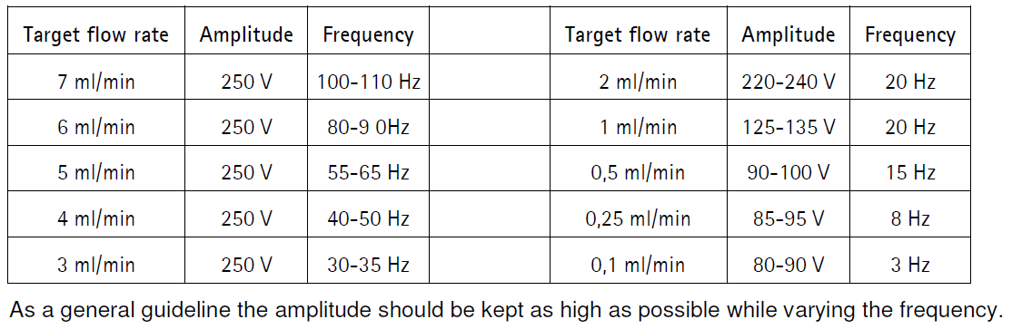

## Flow sensor

| We use a flow sensor from Sensirion. The proposed evaluation kit comes with a USB cable that permits measuring flow with a provided software package. Measured flow can be saved in a csv file, which can be read by the Python control software.   * **Entry and exit**: **XP-202** |  |
| --- | --- |

## Imaging chamber: BIOPTECHS FCS2

| We use the Bioptechs FCS2 flow chamber for imaging on the microscope. We recommend purchasing the starter set, which also contains the temperature control and several silicon gaskets.  Show on the left is the mounted chamber, with the fluidics entry on the right, exit on the left. Temperature control is connected on the top./ |  |
| --- | --- |

* **Entry: soft tubing** + **IDEX P-646 + IDEX P-603 + XP-202**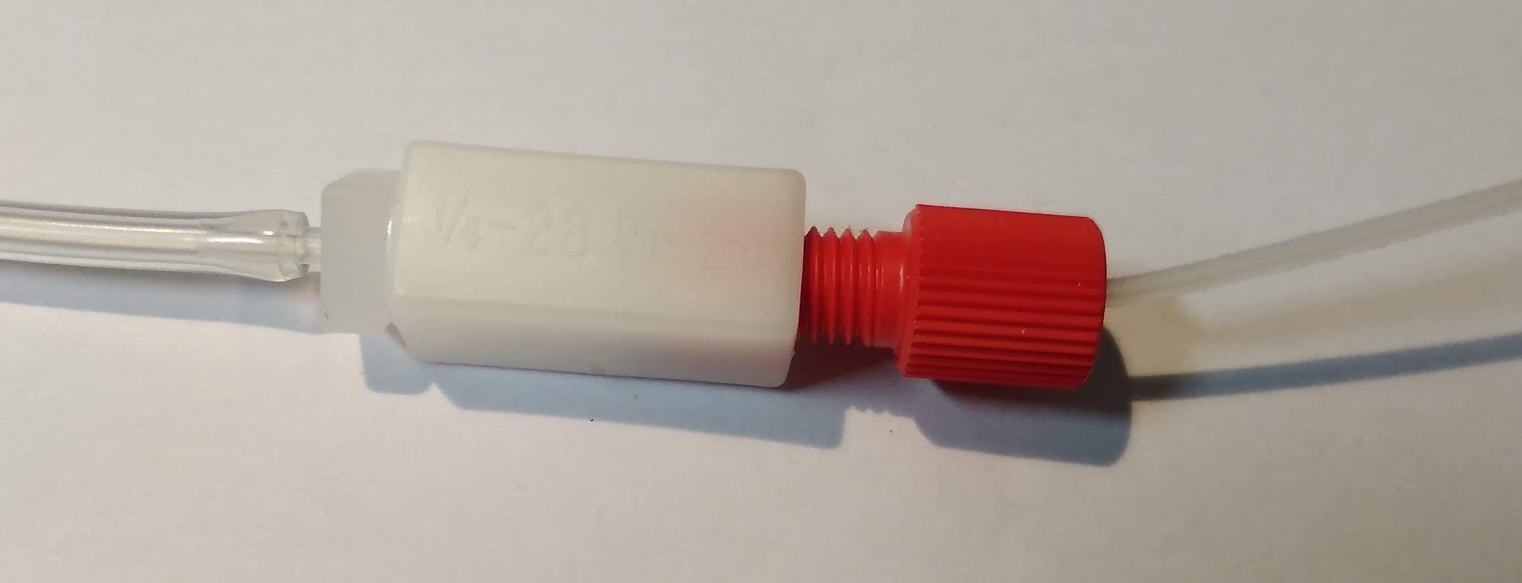
* **Exit:** we use only the soft tubing without any connectors to avoid clocking up, when parts of the samples dislodge.

# Component list

Note: we listed the minimum number of IDEX connectors you will need, ordering a few extra for security might be good.

| **What** | **References** | **Quantity** |
| --- | --- | --- |
| Tubing (fluidics) | Tube TEFZEL/ETFE 1/16" (OD) x 0.50mm (ID) Naturel (0.020" | 5m |
| Clear PVC tubing | McMasterCarr 5233K51. ID1/16“ ID To connect the imaging chamber | 1m |
| Tubing to threaded port | IDEX XP-202 | 20 |
| Syringe adapter | IDEX P-658 | 1 per syringe |
| Male Luer | IDEX P-655 | 2 |
| Barbed to threaded Male | IDEX P-646 | 1 |
| Standard Union for threaded ports | IDEX P-603 | 1 |
| Conica to threaded male | IDEX P-692 | 1 |
|  | LIDS for closing when done |  |
| Syringe holder | Warner Instruments 64-0143 | 1 |
| Robot | CNC 3018 Pro, important to have GRBL support | 1 |
| Needles | Hamilton™ 90523 (Kel F Hub Needles) Ga25 (ID 0.26mm), needle style 3 (blunt), 51mm | 1 (sold by 6) |
| Imaging chamber | BIOPTECHS FCS2 Starter set | 1 |
| Valve positioner | [Hamilton MVP/4 Valve Positioner](http://www.hamiltoncompany.com/search/search_results/MVP4-Valve-Positioner) | 1 |
| Valve | [Hamilton CERAMIC, HVCX, 8-5](http://www.hamiltoncompany.com/search/search_results/VALVE-CERAMIC-HVCX-85-PSD4) | 1 |
| Flow sensor | Sensirion Flow Sensor evaluation kit SLF3S-0600 | 1 |
| Bubble trap | ELVEFLOW Autoclavable Bubble Trap for Microfluidics | 1 |
| Vacuum pump + control | [Bartels mp-Lab! Evaluation Set](https://darwin-microfluidics.com/collections/vendors?q=Bartels) | 1 |
| Serial-to-USB adaptor | USB to Straight-Through RS232 Serial Adapter | 2 |

# Controlling valves and pumps via the serial port

## Which COM port?

In order to control the different components, you will need to know their **COM port** when connected to a computer. This port usually doesn’t change . To see on which port your components are

1. Right click on the Windows Start Icon and select "Device Manager."
2. Open the "Ports (COM & LPT)" Section.
3. Locate the appropriate Device (if you don’t know which one, disconnect and reconnect it) and note which COM port it is connected to.

## Testing your hardware connected to a Serial port

To test a hardware component and if you can communicate with it, you can use dedicated programs that allows you to send commands to serial ports. This allows to test different commands. In the next sections we list some typical commands that can be send to these components.

* **Termite**: simple program to send and receive data to a USB port (<https://www.compuphase.com/software_termite.htm>)
* **Portmon**: a tool to monitor activity on serial ports<https://docs.microsoft.com/en-us/sysinternals/downloads/portmon>
* Some more information for how to **monitor serial port activity**  
  <https://technet.microsoft.com/en-us/sysinternals/bb896644>

Once this works, you can then use our Python control software **automator**. If you buy other hardware than the one listed above, you will likely need to write a new Python class for this hardware. For more details, see the dedicated documentation of **automator.**

### MVP Valves

To communicate with the MVP valve,

* **Baud rate :** 9600 bps
* **Data bits :**8
* **Parity :** none
* **Transmitted text :** append CR

Commands below are for Valve 1

| **Command** | **Serial command** | **Return** |
| --- | --- | --- |
| Initialization commands | /1h30001R  /1h20000R  /1h10000R |  |
| Set valve type 8 way 45 degrees | /1h21003R |  |
| Move to valves position 1 (fastest way) | /1h23001R |  |

RETURN /0@[03]

### Pipette robot

### REGLO Pump

* **Baud rate :** 9600 bps
* **Data bits :**8
* **Parity :** none
* **Transmitted text : append CR**

| **Command** | **Serial command** | **Return** |
| --- | --- | --- |
| Software version | 1# | *String containing REGLO* |
| Set control panel inactive | 1B | * |
| Set flow rate to 1 ml/min fmmmmee ; m Mantisse, e Exponent | 1f1000-3 | Returns 1000E-3 |
| Set revolution counter-clockwise | 1K | * |
| Set revolution clockwise | 1J | * |
| Dispension time in 1/10 of a second → for longer times this has to be in minutes (VM) | 1V2400 |  |
| Starts pump | 1H |  |
| Stop pump | 1I |  |

## 